Name:_____________________ Date:__________


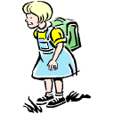

Making Text to Self Connections

The author said: | That reminds me of…

