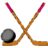
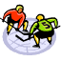
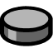
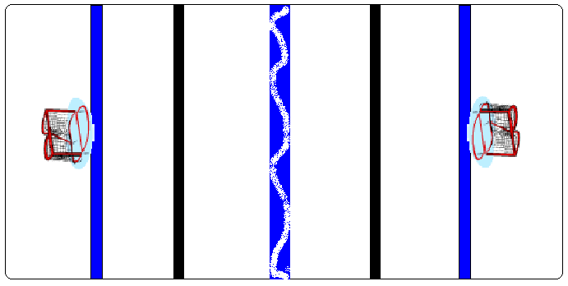 Multiplication Hockey

http://www.geocities.com/athens/thebes/9893

