

My name is________________________________________________

Circle your answer
Over the summer did you go on vacation? | YES | NO
Over the summer did you go to the library? | YES | NO
Over the summer did you go to the movies? | YES | NO
Over the summer did you go swimming? | YES | NO
Over the summer did you eat watermelon? | YES | NO
Over the summer did you ride a bike? | YES | NO
Over the summer did you go to the zoo? | YES | NO
Over the summer did you read books? | YES | NO
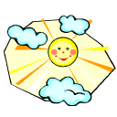

Please bring this completed form with you on the first day of school. We will have fun graphing this information.

