
An Educational Game by Mark and Shelli Temple
of http://www.teachertools.org

Introduction

Eduball is a fun and challenging game for two or more players involving a football type theme. The goal of the game is for your team to score more touchdowns than your opponent. The rules are simple but the application can be used with any subject area. The website http://www.teachertools.org contains all of the materials relating to Eduball as well as EduPak’s containing sets of new questions for the EduBall game.

The Playing Board  The playing board can be downloaded from http://www.teachertools.org in two different forms. The first is suitable for printing on a single piece of 8.5 x 11 typing paper. If you are choosing this method no more assembly of the board is required. The larger size consists of two equal sized parts that printout on two 8.5 x 11 pieces of paper. This method requires some form of assembly. The most simple is to cut the two pieces of the playing board out and tape them together at the 50 yard line. For a more permanent and portable playing surface, it is best to assemble in a standard letter sized file folder, attaching one side of the playing board to each of the inside panels of the folder so that the 50 yard line meets on the folding crease. This allows you to create an extremely sturdy playing board to use over and over. Laminate for increased durability. | 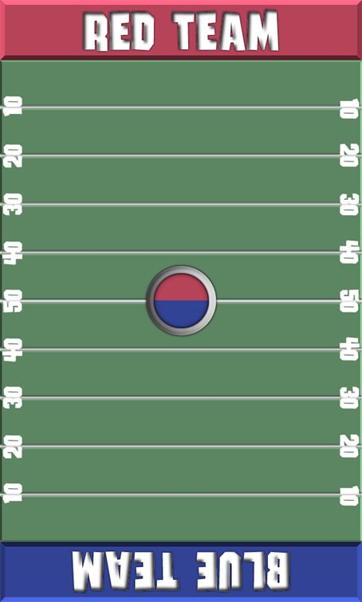

The Players  Each team is represented by a marker which looks like the examples to the right. The assembly of the markers is simple. Download and print the marker graphics from the website http://www.teachertools.org. Cut along the outside black line separating the player pieces. Next fold along the internal black lines. The shorter area acts at a tab for either gluing or taping the piece so that it forms a free standing triangle. For a more sturdy playing piece trying printing the players on cardstock. This makes more solid, durable tokens. Also it is enjoyable to personalize your own tokens adding a unique touch to each game. | 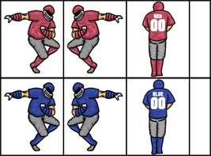

Rules of Engagement

- Each player starts by placing their teams marker facing the 50 yard line as marked on the playing board. One player takes and shuffles the stack of EduPak question cards. A token, usually a coin is flipped to determine which team has the “ball” first.

- The player with the ball is now referred to as the Offensive player and the other player takes the place of Defensive player. The defensive player draws a card from the top of the deck and reads the question to the offensive player. If the question is mathematical in nature the player is allowed and suggested to work the problem out on paper. If the offensive player answers the question correctly his teams token advances 10 yards as the defensive player moves his token back as well. If the offensive player fails to answer the question both teams tokens remain at the same place. If the offensive player fails to answer two consecutive questions then a turnover is cause in which control of the “ball” moves to the other team, and they now receive the questions.

- If a player advances his teams token in this manner to his/her endzone(0 yard line, the area labeled with the team name) a touchdown is scored for that players team. As with football each touchdown is worth 6 points unmodified. At the players option he/she may receive an additional question upon entering the endzone. If the player answers correctly, an additional point is added to their teams score.

- Gameplay continues by placing the two team tokens facing the 50 yard line once again. The player who scored the touchdown now reads the questions while the other has control of the “ball” and tries to answer.

- The winner of the game is the player that scores the largest amount of points in a predetermined time period. Gameplay may be divided into timed quarters like a real ball game or can follow any format you wish. It is however better to set some form of predetermined format instead of allowing the game to go on however long the players wish.
Variations and Ideas

Originally designed for two players this game also adapts well to equal sized teams. For example, trying dividing the classroom into small groups of 3 to 5. Have each group pick a team name. Have the different groups compete in a tournament bracket, awarding the winning team a small treat.

EduBall is a great way to study for an impending test and relieve tension at the same time. Try producing your own EduPak questions relating to subject matter that a test will cover. Make a tradition that an EduBall tournament is held the day before each test, and watch your student show more interest in learning the class material.

