  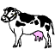      Bb | Cc | Dd | Ff
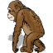    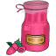    Gg | Hh | Jj | Kk
        Ll | Mm | Nn | Pp
      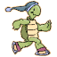  Qq | Rr | Ss | Tt
  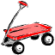      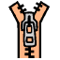  Vv | Ww | Xx | Yy
 | Ww | Xx | Zz
Teaching is a Work of Heart – http://www.geocities.com/athens/thebes/9893

