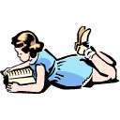
Skip the word

Sam slept _____ the stars.

