http://www.geocities.com/athens/thebes/9893

Reading at Home
October



Name: ________________________________________

Dear boys and girls,

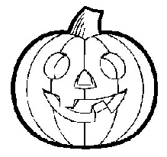
This month color one pumpkin each time you read at home for 15 minutes. You can read from any book you would like. Remember to bring this back to school when it is finished for your reward.

Parent’s Signature:________________________________________
This is to verify that my child has read at home this month. Thanks!

