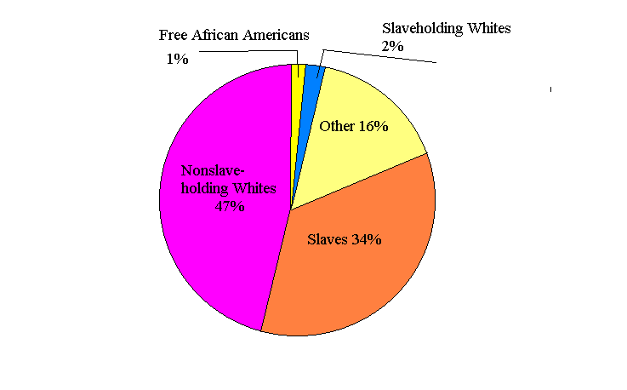
TOTAL POPULATION

C:/MSWORD/Slavery/LW/00

