Name _______________________________
Hour ________________________________
Date Due ____________________________

Instructions:

Each student or group of students must create an ABC Book of Geometry. Each letter must have a term with its definition, pictures, and examples. You may include photographs of objects, such as a picture of a door for a rectangle or similar items. An example has been done for you below. Please attach this form to your finished project for grading purposes.

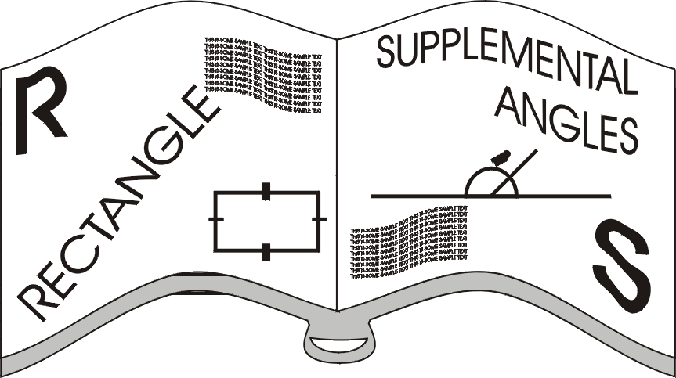

ABC Book of Geometry Grading Rubric

Mathematical Accuracy /20

Neatness /20

Creativity /20

Aesthetically Pleasing /20

Effort /20

Total /100

